# **LAB SESSION 01: Chatter Bot**

**Date of the Session: / / Time of the Session: to**

**Pre-Lab:**

* 1. Write a python program-

1. To check whether the given year is a leap year or not?

INPUT: 1990

OUTPUT: Not a leap year

1. To check whether the given number is prime or not?

INPUT: 13

OUTPUT: Prime number

* 1. Execute the following string operations by writing an efficient python program by using switch case.
  2. Convert the input string into upper case.
  3. Convert the input string into lower case.
  4. Check whether all the characters of the input string are in upper case.
  5. Check whether all the characters of the input string are in lower case.
  6. Replace the string "INTELLIgence" by “Neural Network”.
  7. Check whether the given string starts with “T”.
  8. Check whether the given string ends with “e”.
  9. Convert the first letter of the input string into capital letter.
  10. Convert the lower-case characters to upper case and vice versa.

INPUT:” aRTificial INTELLIgence”

OUTPUT:

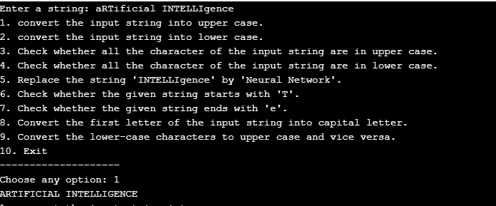

### Writing space for the Problem:(For Student’s use only)

**In-Lab:**

1. Monty is a student at K L University, as she is facing some inconvenience in choosing her courses for specialization and its global certifications in CSE Department, help him to find a course and global certification that is required for the specialization she is interested in, by using a simple Chatbot.

Sample Output:

: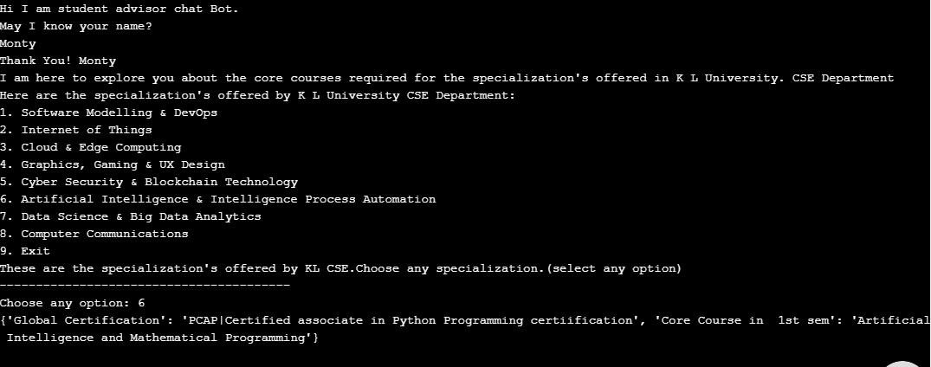

### Writing space for the Problem:(For Student’s use only)

1. You’re facing many issues with your laptop and you have no idea what’s happening to it, so you need to send a request by having a conversation with the chat bot of the service company to fix this issue. Based on the conversation, develop a python code to implement a simple chatter bot using functions (don’t use modules and packages). For example, if you give “Hi” it must print “Hello”. For every iteration it must take a new question as input and if you say “Bye”, the loop must be terminated.

**Post-Lab:**

1. Monty is a student. He wants to know his age in years, days, hours, minutes and seconds from his birthdate till date and print a few lines about his favorite color. Create a Chatbot to solve Monty’s Problem.

Sample Output:

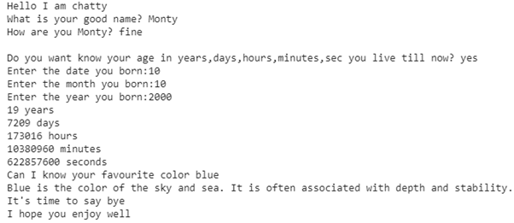

### Writing space for the Problem:(For Student’s use only)

1. Shruthi is assigned to develop a intelligent agent(like a chatterbot) for the addition of two integers provided the agent must follow some conditions: the agent work will start with reflex to greeting from user and continues in his state(prime work addition of two numbers) until user provide agent with stop option.

### Writing space for the Problem:(For Student’s use only)

*(For Evaluator’s use only)*



Signature of the Evaluator Date of Evaluation:

|  |  |
| --- | --- |
| Comment of the Evaluator (if Any) | Evaluator’s Observation |
| Marks Secured: out of | |
| Full Name of the Evaluator: | |

# **LAB SESSION 02: Water Jug Problem**

**Date of the Session: / / Time of the Session: to**

**Pre-Lab:**

1. You have two jugs with capacities x and y liters. There is an infinite amount of water supply available to you. Now you need to determine whether it is possible to measure z liters using these two jugs. If z liters of water are measurable, you must have z liters contained within one or both jugs by the end.

We can do these few operations −

• Fill any of the jugs fully with water.

• Empty any of the jugs.

• Pour water from one jug into another till the other jug is completely full or the first jug itself is empty.

1. Write an algorithm to solve the water jug problem?

**In-Lab**:

1. A Water Jug Problem: You are given two jugs, a 4-gallon one and a 3-gallon one, a pump which has unlimited water which you can use to fill the jug, and the ground on which water may be poured. Neither jug has any measuring markings on it. How can you get exactly 2 gallons of water in the 4-gallon jug?

Let X represent the content of the water in 4-gallon jug.

Let Y represent the content of the water in 3-gallon jug.

Write a program in python to define a set of operators (Rules) that will take us from one state to another:

Start from initial state (X=0, Y=0)

Reach any of the Goal states

(X=2, Y=0)

(X=2, Y=1)

(X=2, Y=2)

(X=2, Y=3)

### Find the minimum number of steps to reach any the above mentioned goal states.

### Writing space for the Problem:(For Student’s use only)

1. A Water Jug Problem: You are given three jugs, a 4-gallon one and a 5-gallon one .a pump which has unlimited water which you can use to fill the jug, and the ground on which water may be poured. Neither jug has any measuring markings on it. How can you get exactly 1 gallons of water in the 5-gallon jug?

Let X represent the content of the water in 4-gallon jug.

Let Y represent the content of the water in 5-gallon jug.

Write a program in python to define a set of operators (Rules) that will take us from one state to another:

Start from initial state (X=0, Y=0)

Reach any of the Goal states

(X=1, Y=0)

(X=1, Y=1)

(X=1, Y=2)

(X=1, Y=3)

(X=1,Y=4)

### Find the minimum number of steps to reach any the above mentioned goal states.

### Writing space for the Problem:(For Student’s use only)

## Post-Lab:

1. A Water jug problem with 3 gallon: You are given three jugs, a 12-gallon one and an 8-gallon one and a 5-gallon one, a pump which can supply unlimited water that can be used to fill the jugs, and a ground on which water can be disposed. Neither jug has any measuring markings on it. Implement a python code to get exactly 6 gallons of water in any of the jug.
2. MIN AND MAX

You are given a 2-D array with dimensions X.  
Your task is to perform the *min* function over axis and then find the *max* of that.

Input Format

The first line of input contains the space separated values of and.  
The next line contains space separated integers.

Output Format

Compute the *min* along axis and then print the *max* of that result.

Sample Input:

4 2

2 5

3 7

1 3

4 0

Sample Output:  
 3

### Writing space for the Problem:(For Student’s use only)

*(For Evaluator’s use only)*



Signature of the Evaluator Date of Evaluation:

|  |  |
| --- | --- |
| Comment of the Evaluator (if Any) | Evaluator’s Observation |
| Marks Secured: out of | |
| Full Name of the Evaluator: | |